ELCTRIC DATA VECHICLE DATA ANALAYSIS

Introduction:
Exploratory Data Analysis (EDA) is essential for understanding electric vehicle data, identifying adoption trends, and generating insights that support sustainable transportation planning and policy decisions. In this project, we implement key EDA techniques on the Electric Vehicle Population dataset sourced from a structured CSV file. This iterative process involves summarizing, visualizing, and exploring the data to uncover patterns, anomalies, and relationships among important attributes such as electric range, model year, manufacturer, vehicle type, and base price. Through EDA, the project aims to gain a deeper understanding of electric vehicle growth, performance characteristics, and market behavior

▪ Importing data and Exporting data
▪ Data cleaning
▪ Data transformation
▪ Descriptive statistics
▪ Basic visualization
▪ Advanced visualization
▪ Interactive visualization
▪ Probability analysis
▪ Modelling-clustering(K-Means)
▪ Summary & insights

Electric Data vechicle data analysis from: gov.in
Project Structure:
1).Importing and Exporting Data:
This project involves importing electric vehicle data from structured datasets such as CSV files to analyze trends in electric vehicle adoption and performance. The imported data is cleaned, transformed, and standardized to ensure consistency and accuracy for further analysis. Key electric vehicle attributes such as model year, manufacturer, electric range, vehicle type, and base price are processed and stored in an efficient format. Exporting functionality is implemented to generate structured outputs in formats like CSV or Excel, enabling easy sharing, reporting, and visualization of insights. These data import and export mechanisms ensure seamless data flow across different stages of the project, supporting reliable analysis of electric vehicle trends and data-driven decision-making.

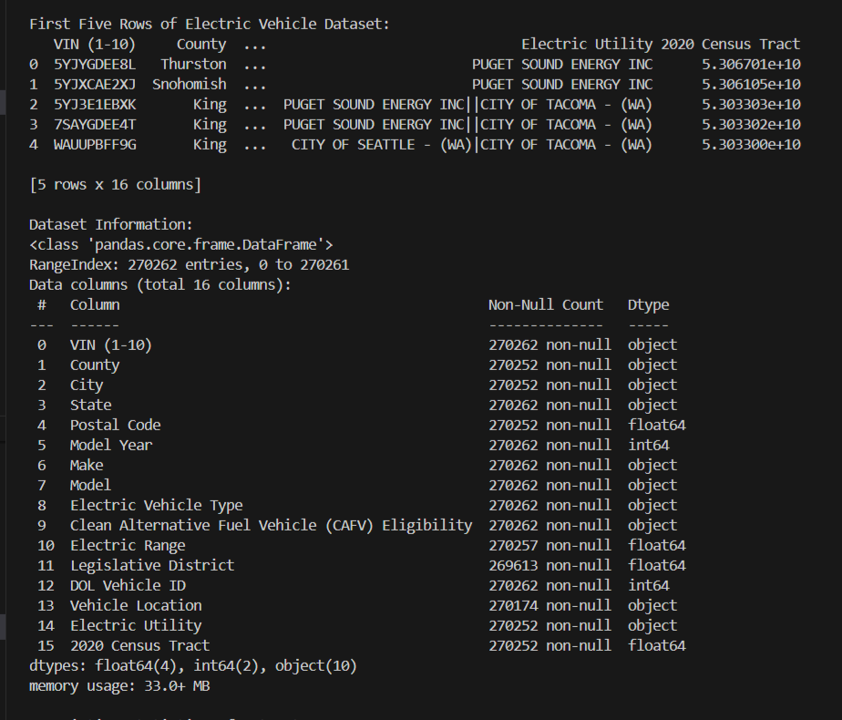

2).Data Cleaning:
Cleaned file created:elect_cleaned.csv
Data cleaning is a crucial step in this project to ensure the accuracy and reliability of the electric vehicle dataset. The raw data often contains missing values, duplicate records, and inconsistent entries that can affect the quality of analysis. To address these issues, missing values are identified and handled using appropriate techniques, and duplicate records are removed to avoid redundancy. Inconsistent data types and formatting issues are corrected to maintain uniformity across the dataset. Irrelevant or noisy attributes are filtered out to focus on key electric vehicle features such as electric range, model year, manufacturer, and base price. These data cleaning steps ensure that the dataset is well-structured, accurate, and ready for meaningful analysis and visualization.

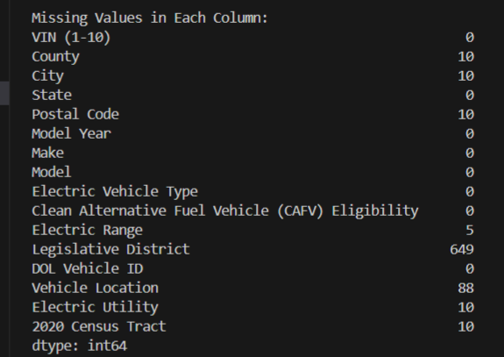

3) Data Transformation:
Data transformation is an important step in preparing the electric vehicle dataset for effective analysis. After cleaning, numerical attributes such as electric range and base price are transformed using scaling and normalization techniques to ensure uniformity. Discretization is applied to continuous variables to convert them into meaningful categories, improving interpretability. Categorical features such as vehicle type and manufacturer are encoded for analytical purposes. These transformations enhance data consistency and make the dataset suitable for visualization and machine learning models. Overall, data transformation helps improve analytical accuracy and insight generation.

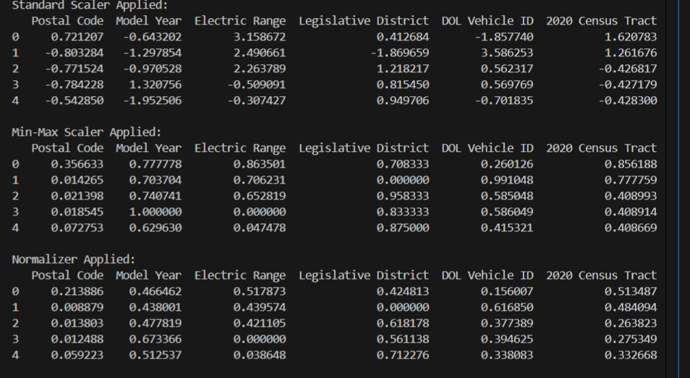

4) Descriptive Statistics:
Descriptive statistics are used to summarize and understand the key characteristics of the electric vehicle dataset. Statistical measures such as mean, median, minimum, maximum, and standard deviation are calculated for numerical attributes like electric range and base price. These measures provide insights into the central tendency and variability of the data. Frequency counts are also used to analyze categorical features such as manufacturer and vehicle type. Descriptive statistics help identify data patterns, trends, and unusual values. This analysis forms the foundation for further visualization and modeling.

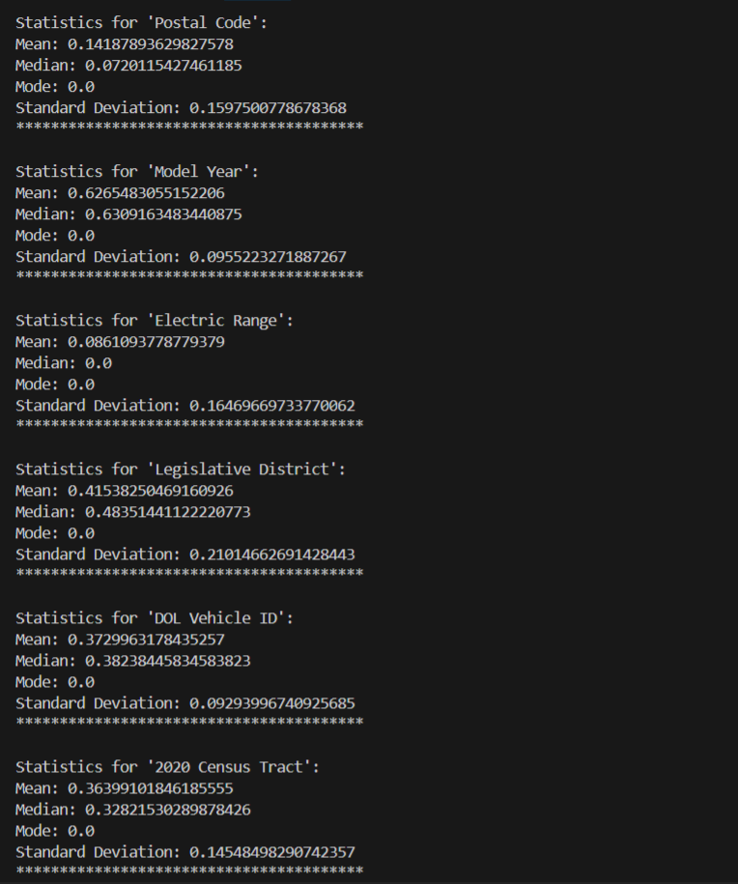
5) Basic Visualization:
Basic visualization techniques are used to visually explore the electric vehicle dataset and identify key patterns. Line plots are applied to analyze trends in electric vehicle growth across different model years. Bar charts are used to compare manufacturers and the number of registered electric vehicles. Histograms help in understanding the distribution of electric vehicle range values. These visualizations simplify complex data and make trends and comparisons easier to interpret. Basic visual analysis provides a clear overview of the dataset and supports initial insights.

(i).Line Plots:
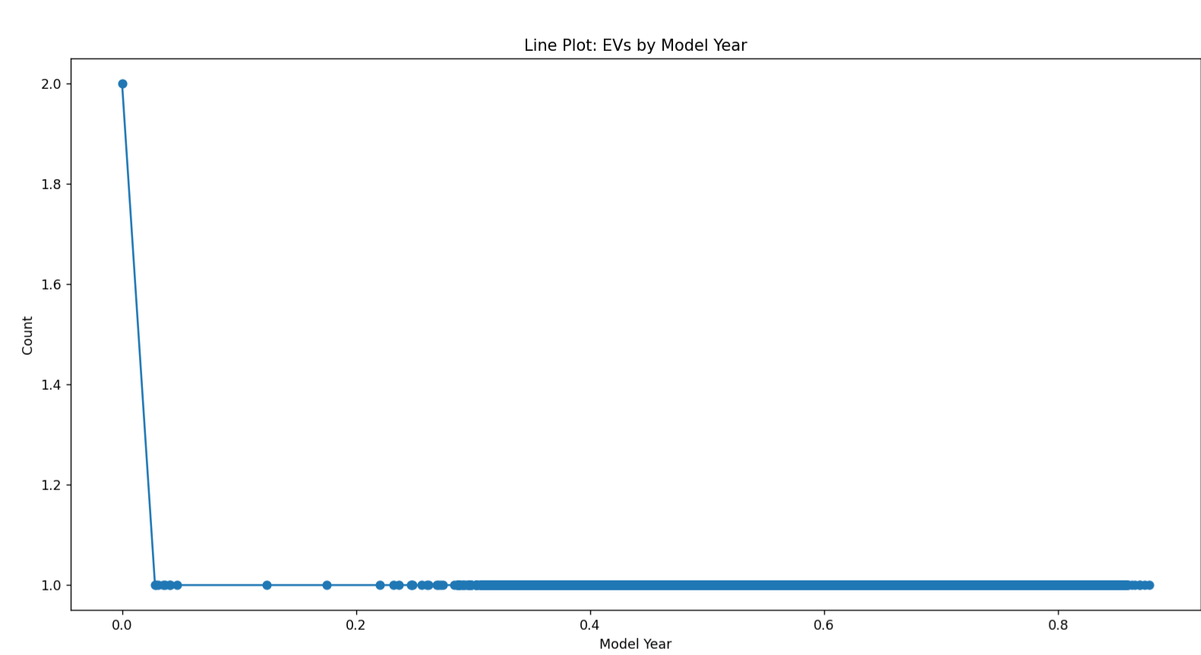

(ii).Bar Charts:

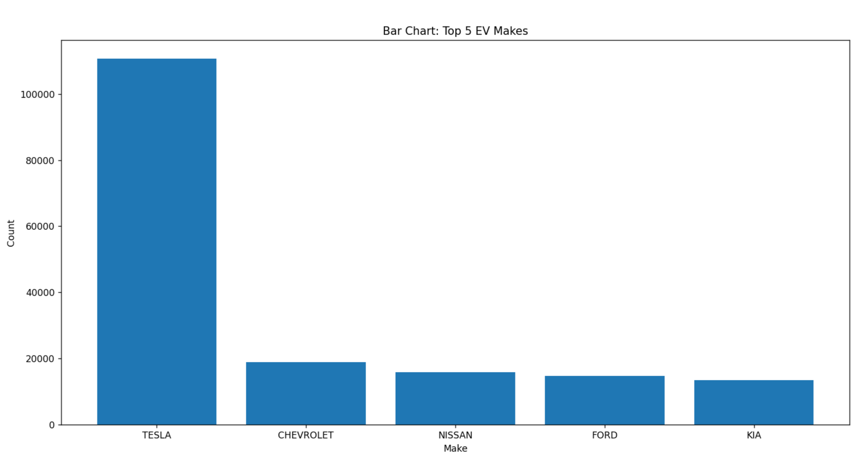

(iii).Histrogram:
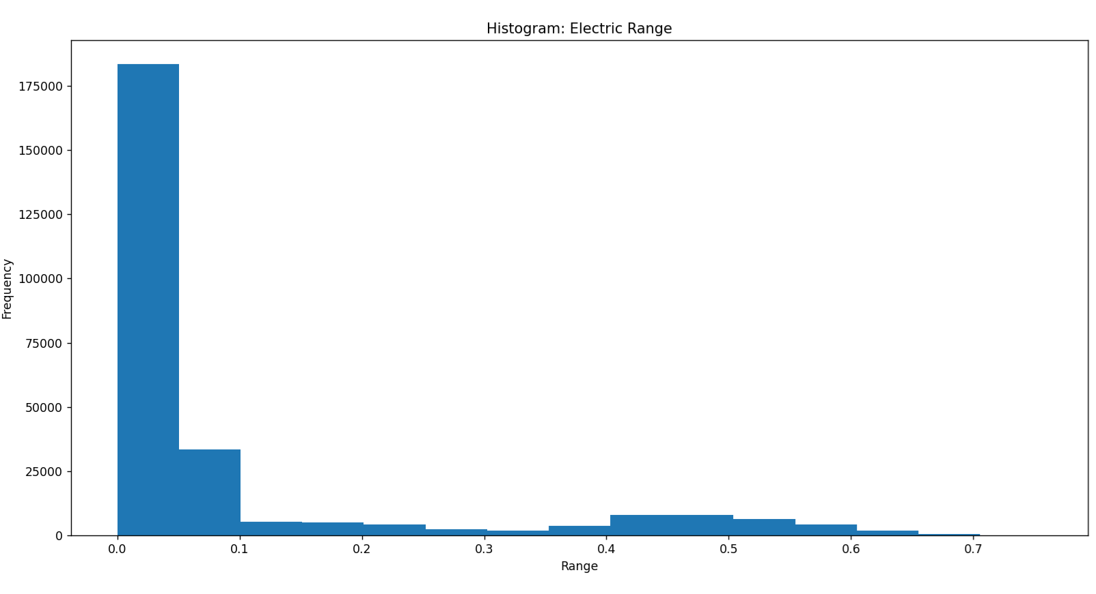

6) Advanced Visualization:
Advanced visualization techniques are used to gain deeper insights into the electric vehicle dataset. Visual tools such as heatmaps and scatter plots help analyze relationships between numerical variables like electric range, base price, and model year. Correlation heatmaps highlight strong and weak relationships among features, making hidden patterns visible. These visualizations allow multi-dimensional analysis and better comparison across variables. Advanced visualization enhances analytical depth beyond basic charts. It supports more informed interpretation and decision-making.

(i).Pair plots:
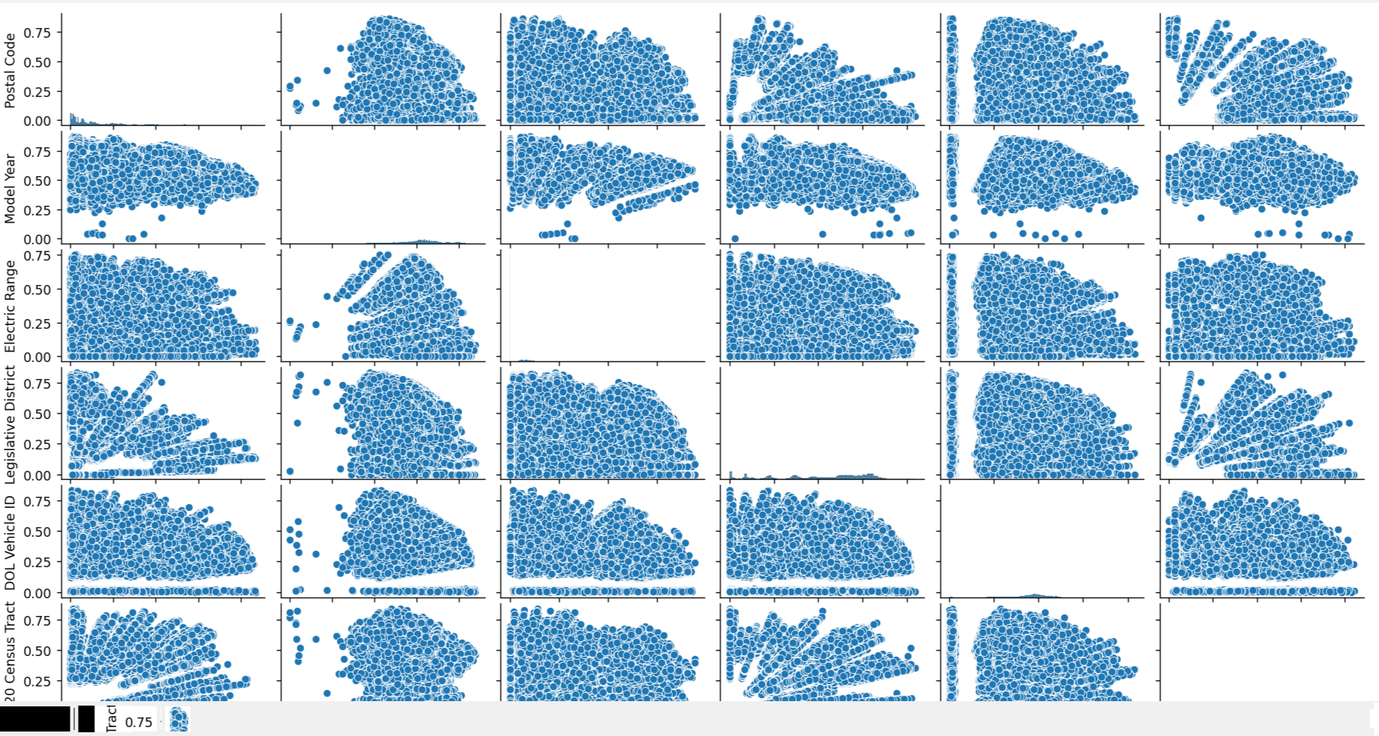

(ii)Heatmaps(correlation)
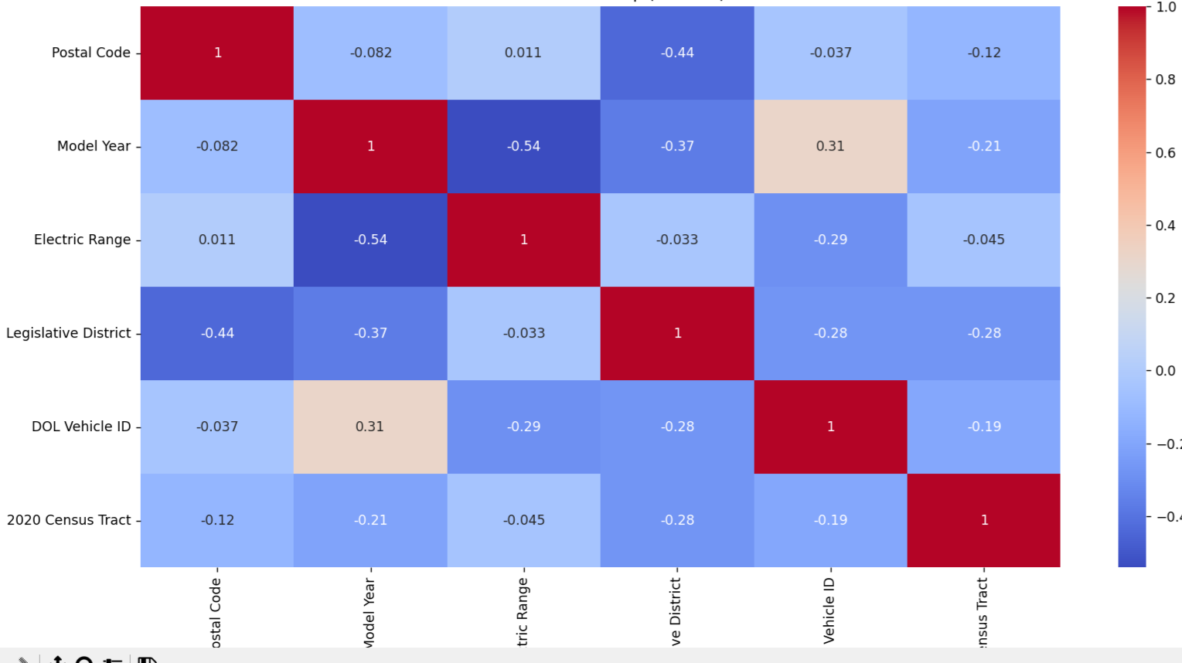

(iii)Heatmap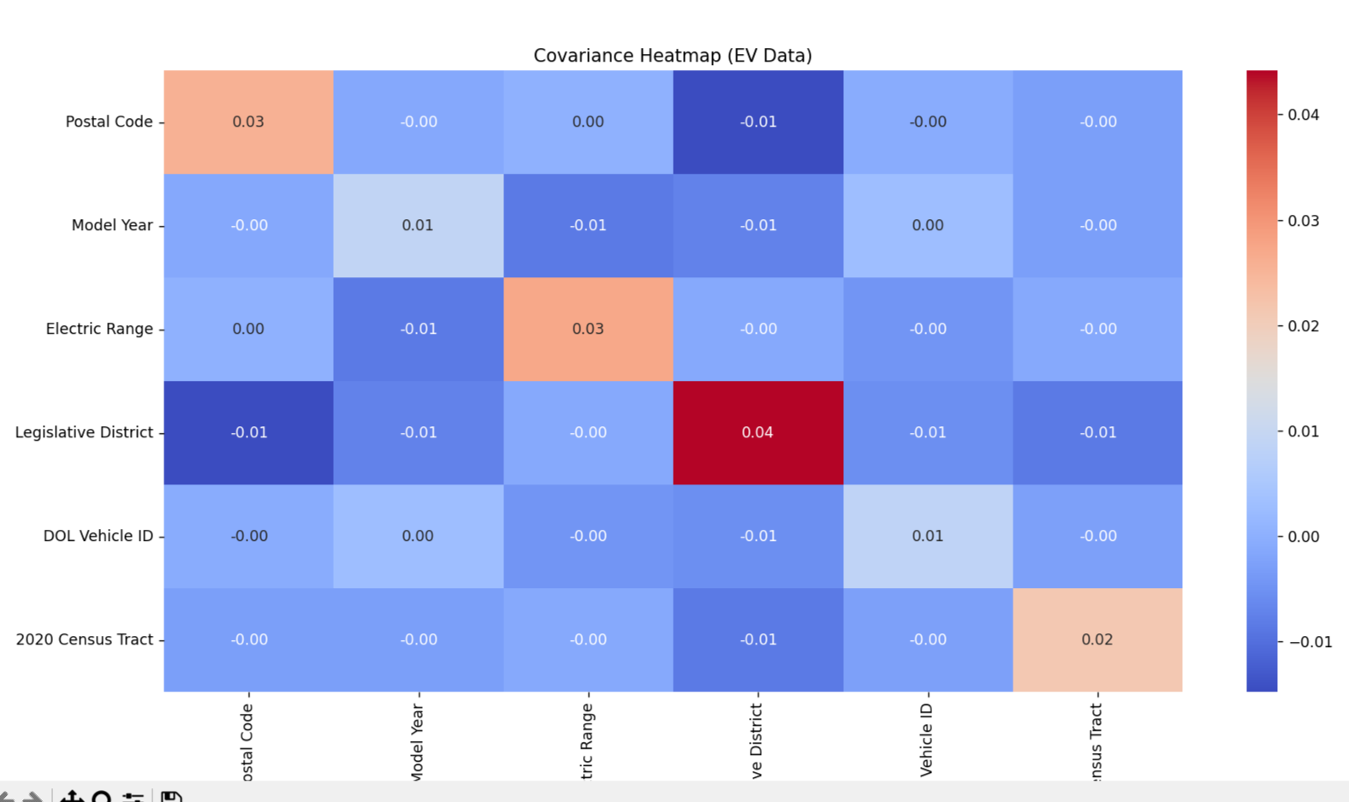

7) Interactive Visualization:
Interactive visualization is used to enable dynamic exploration of the electric vehicle dataset. Interactive charts allow users to filter, zoom, and hover over data points to view detailed information. This helps in comparing electric vehicle attributes such as manufacturer, electric range, and model year more effectively. Interactive dashboards improve user engagement and understanding of complex data. They support deeper analysis by allowing real-time interaction with the dataset. Overall, interactive visualization enhances clarity and analytical insight.

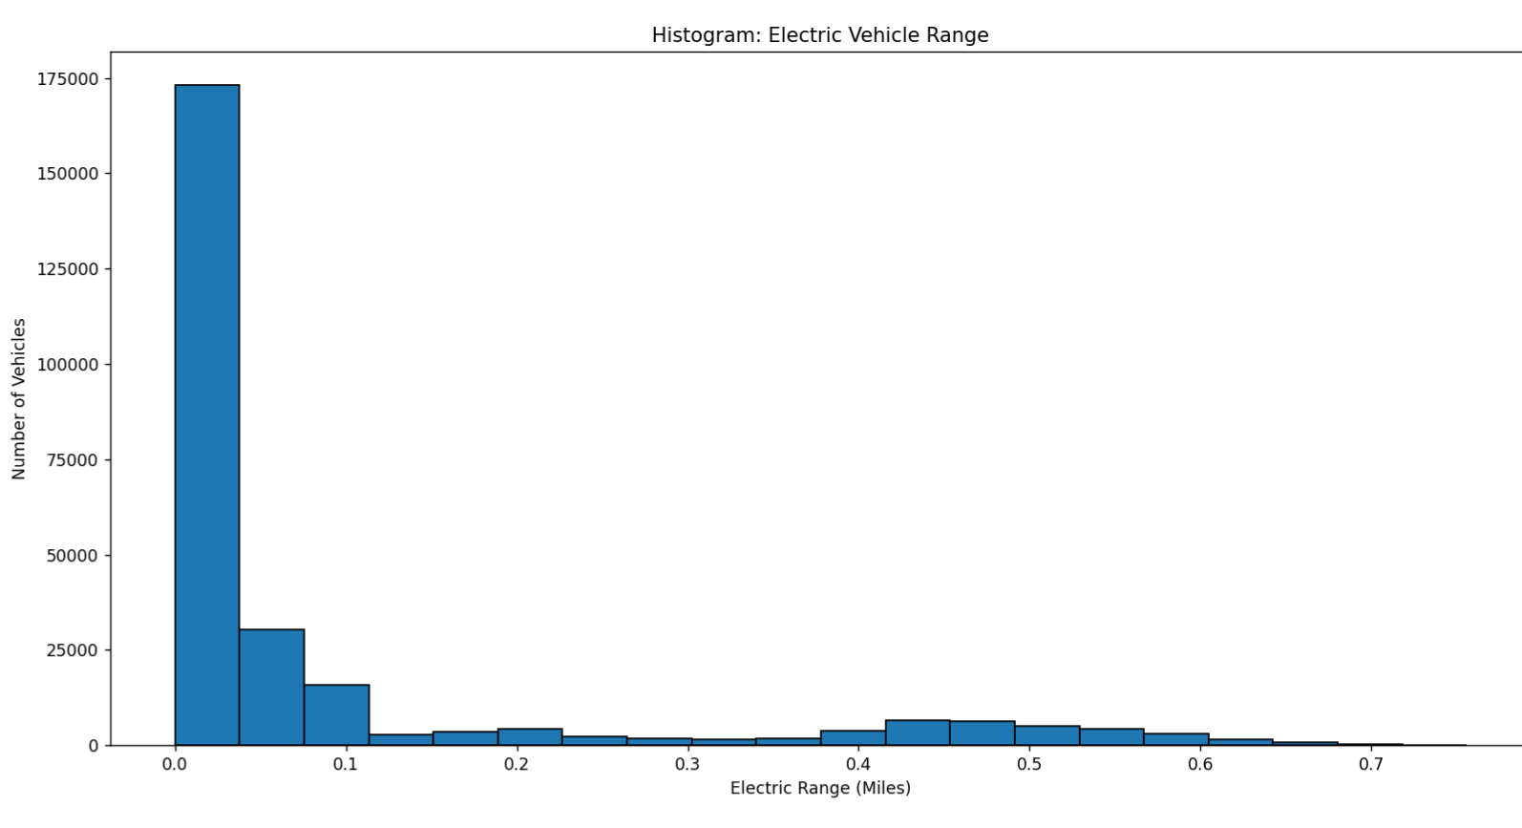

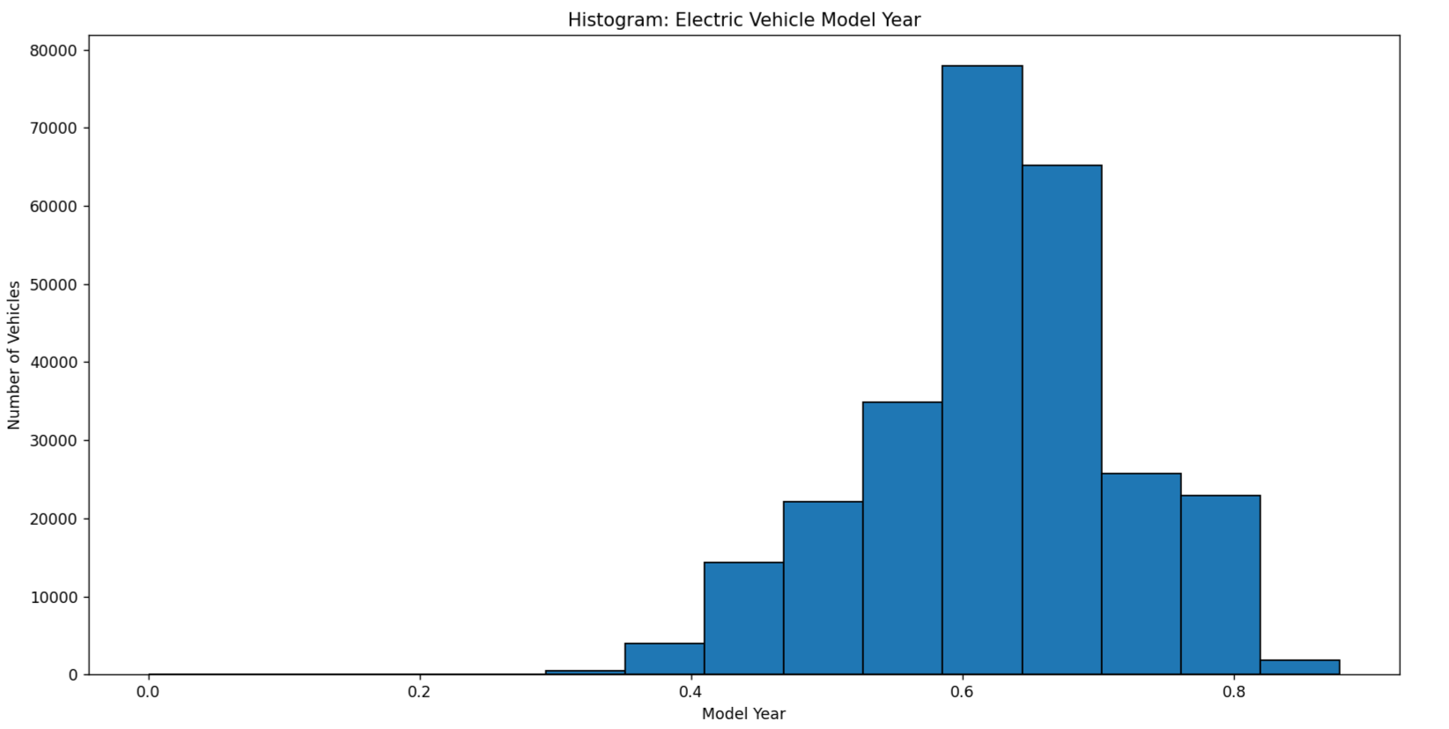

8) Probability Analysis:
Probability analysis is used to measure the likelihood of specific outcomes in the electric vehicle dataset. It helps estimate probabilities such as the chance of a vehicle having an electric range above a certain threshold. This analysis supports uncertainty handling and risk assessment in data-driven decisions. By applying probability concepts, patterns in electric vehicle performance and adoption can be better understood. It also aids in forecasting trends based on historical data. Overall, probability analysis enhances predictive understanding of the dataset.

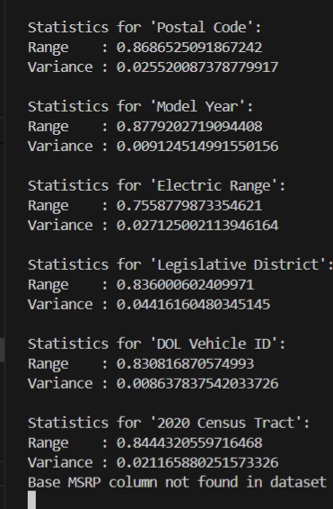

Probability analysis Histrogram:
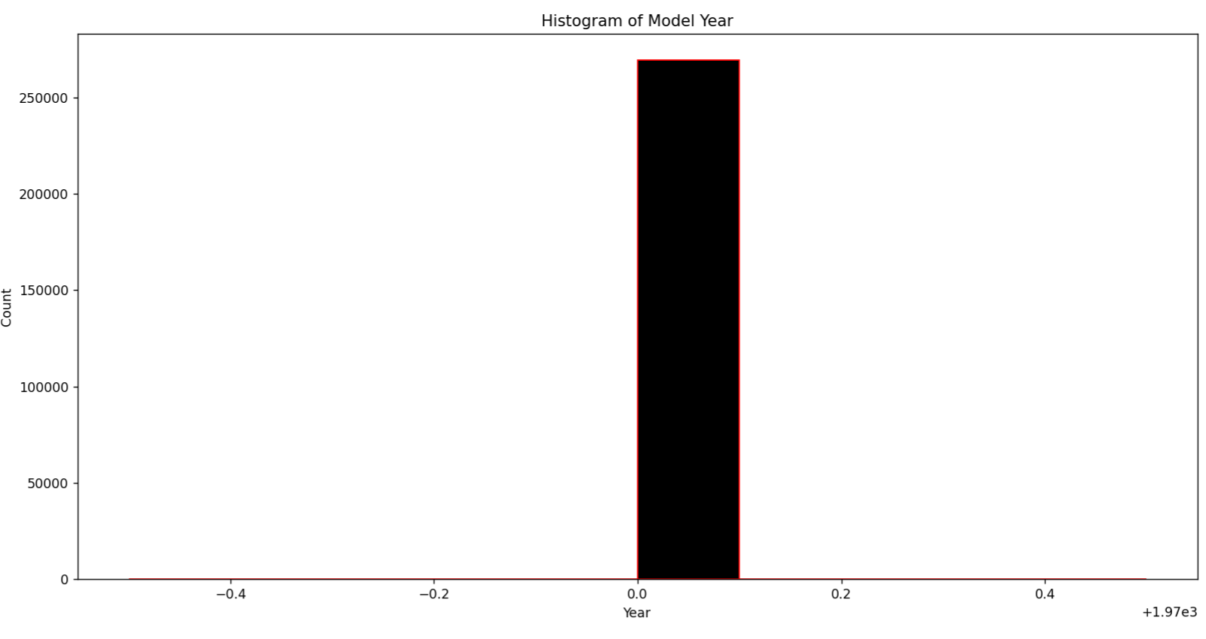

9) Modelling – Clustering (K-Means):
K-Means clustering is used to group electric vehicles based on similar characteristics such as electric range, model year, and price. This technique helps identify patterns and segments within the electric vehicle market. Vehicles with similar performance and specifications are grouped into the same cluster. K-Means minimizes intra-cluster distance while maximizing separation between clusters. The clustering results help understand market segmentation and consumer preferences. This model supports strategic analysis and decision-making.

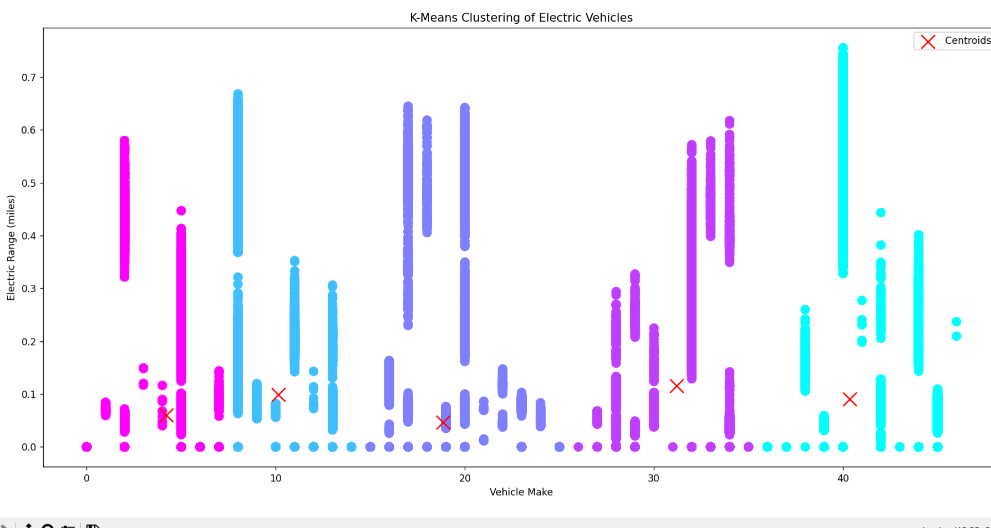

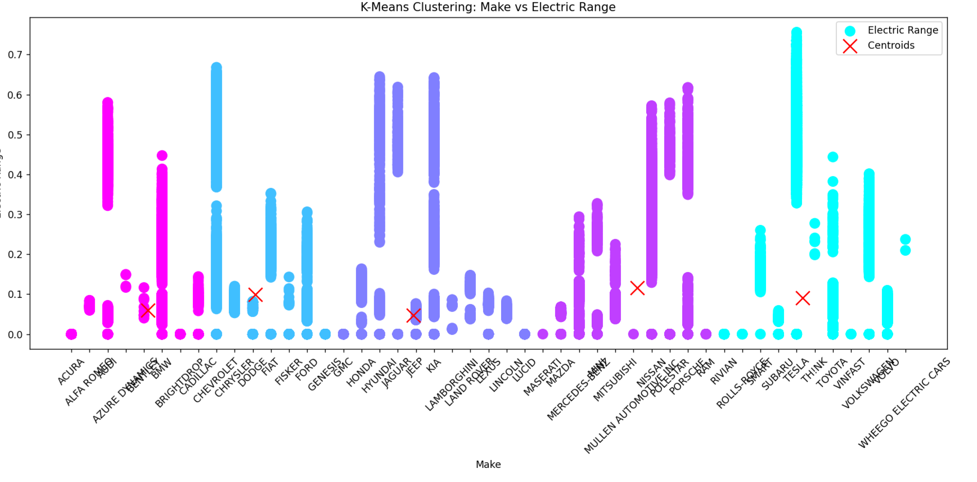

Summary:
This project focuses on analyzing an electric vehicle dataset to extract meaningful insights using data analysis and visualization techniques. The data was cleaned, transformed, and standardized to ensure accuracy and consistency. Descriptive statistics and visualizations were used to understand trends in electric range, model year, and pricing. Probability analysis helped estimate the likelihood of key outcomes within the dataset. K-Means clustering was applied to group similar electric vehicles based on numerical features. Overall, the project provides valuable insights into electric vehicle patterns and market segmentation.

